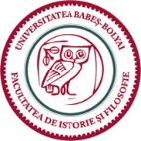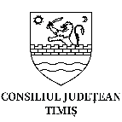
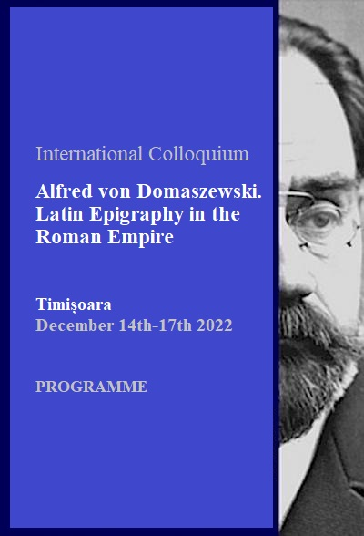

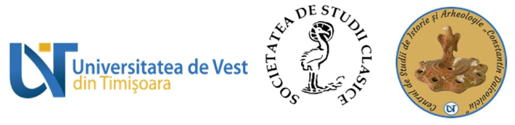
INTERNATIONAL COLLOQUIUM

Alfred von Domaszewski. Latin Epigraphy in the Roman Empire

(Timișoara, December 14th-17th 2022)

Organizers:

Timiș County & National Museum of Banat Timișoara
dr. Călin Timoc

Babeș-Bolyai University Cluj-Napoca, Faculty of History and Philosophy, Departement of Ancient History and Archaeology
Prof. dr. Sorin Nemeti

POSTERs
[1] Mariana Balaci (Timișoara), Une brique avec une écriture cursive découverte à Dalboșeț (dép. de Caraș Severin)
[2] Marius Gheorghe Barbu, Cătălin Rișcuța, Cătălin Cristescu, Antoniu Tudor Marc (Deva), A graffiti from the beginning of the 2nd century discovered in the vicinity of Micia
[3] Dorel Bondoc, Gabriela Filip (Craiova), A stamped Roman amphora belonging to the Εφηβος producer, discovered at Cioroiu Nou
[4] Victor Bunoiu (Drobeta Turnu-Severin), Florian Matei-Popescu (București), Brickstamps from the Roman Bridge pillars from Drobeta
[5] Ana C. Hamat, Ștefan Georgescu (Deva), The fate of the monuments of ancient Tomis in the 4th century. Preventive archaeological research from Constanța - Bd. Aurel Vlaicu, no. 158 - Hornbach store (2021-2022)
[6] Stefan Georgescu, Ana C. Hamat (Deva), New discoveries of Roman Lamps near Tomis, dwellings from boulevard A. Vlaicu, IInd century AD until the end of VII th century AD.
[7] Simona Regep (Timișoara), Brickstamps discovered at Praetorium-Mehadia (Caraș-Severin County)
[8] Călin Timoc, Sergiu Enache (Timișoara), Graffiti Inscriptions on Usual Roman Pottery from Tibiscum-Jupa
[9] Dan Dana (Lyon), Dan Deac (Zalău), Literacy and writing habits among the military on the northern frontier of Dacia

14th of December: arrival of the participants
(accomodation at Hotel ATLAS – from 13:00)
19:00 Welcome – dinner @ Restaurant of Hotel ATLAS

15th of December: Colloquium opening
10:00 REGISTRATION @ National Museum of Banat & visiting the exhibition of gems and cameos from Roman Dacia, curator: Ștefana Cristea
- From 11 o'clock the opening of the scientific event with the unveiling of Domaszewski's memorial plaque at the military chapel in „Piața 700” [speeches of the organizers, representatives of WUT, County Council, City Hall and Honorary Consulate of Austria, etc.]

Lunch @ Restaurant of Hotel ATLAS (between 13:00 – 15:00)

Conference Hall @ Hotel ATLAS
Plenary Session: Alfred von Domaszewski and the researchers of his time
Chair: Florian Matei-Popescu
15:00 – 15:30 Kövecsi Gerzson Ákos, The contribution of archaeologists and antiquarians from Transylvania to the creation of the CIL III Supplementum coordinated by Alfred von Domaszewski
15:30 – 16:00 Matyas Joszef, Aspects regarding the collaboration between Torma Károly and Theodor Mommsen in redacting the volume CIL III
16:00 – 16:30 Kovács Péter, Alfred von Domaszewski and the Pannonian milestones
16:30 – 17:00 Szabó Csaba, Alfred von Domaszewski and Béla Cserni:Authority and academic networks in the late 19th century Transylvanian research
17:00 – 17:30 Forisek Péter, András Alföldi at the University of Debrecen (1923-1930)

Coffee break 17:30-18:00

18:00-18:30 * POSTER SESSION & Discussions
18:30-19:30 * Books release & Discussions
Dorel Bondoc, Cărămizile ștampilate de la Slăveni, Syntech Printhouse, Craiova, 2022.
Ioan Piso, Adrian Ardeț, Călin Timoc, IDR Appendix, vol.III, Mega Publishing House, Cluj-Napoca, 2020.

19:30 – Festive Dinner @ Hotel ATLAS

16th of December: Colloquium presentations
Conference Hall @ Hotel ATLAS
Plenary Session: New epigraphical discoveries
Chair: Kovács Péter
9:00 – 9:30 Florian Matei Popescu, Radu Ota, Gabriel Balteș, Horia Ciugudean, Ovidiu Oargă, A Roman altar discovered at Galda (Alba County, Romania)
9:30 – 10:00 Liviu Petculescu, C. Antonius Crispinus veteran and magister pagi
10:00 – 10:30 Ioan Piso, Ovidiu Țentea, The epigraphic material of the numeri Palmyrenorum in Roman Dacia
10:30 – 11:00 George Cupcea, The legionary centurionate one century after “Rangordnung” and a list of centurions from Apulum

Coffee break 11:00-11:30

Plenary Session: Votive epigraphical materials
Chair: Radu Ardevan
11:30 – 12:00 Szabó Ádám, The Roman religion and the epigraphical material
12:00 – 12:30 Ștefana Cristea, Sorin Nemeti, Inscriptions on the gems and cameos from National Museum of Banat
12:30 – 13:00 Denisa Murzea, Women in the “cloud” around the Roman world
13:00 – 13:30 Lucia Carmen Ardeț, Adrian Ardeț, Temples and cult buildings from Tibiscum
13:30 – 14:00 Călin Timoc, About a recently rediscovered votive inscription from the Herculane Baths (IDR III/1 66 = CIL III 1573)

Lunch @ Restaurant of Hotel ATLAS (between 14:00 – 15:30)

Conference Hall @ Hotel ATLAS
Plenary Session: Old epigraphical discoveries reinterpreted
Chair: Ioan Piso
15:30 – 16:00 Vladimir P. Petrović, Les plus anciennes bornes milliaires de la Mésie supérieure : la contribution sur la question de l’ancienneté du réseau routier dans les Balkans centraux
16:00 – 16:30 Florin Fodorean, Pecunia sua fecit. Aspects regarding the road building activities during Trajan’s reign reflected through milestones
16:30 – 17:00 Radu Ardevan, Remarks on an inscription of Ulpiana (Upper Moesia)
17:00 – 17:30 Isabelle Paulsen, Jeremy M. Hutton, Tracing the Life of a Soldier: P. Ael. Theimes at Ulpia Traiana Sarmizegetusa and Tibiscum?

Coffee break 17:30-18:00

Plenary Session: Military epigraphy
Chair: George Cupcea
18:00 – 18:30 Chiara Cenati, Florian Matei Popescu, Military history from square brackets: some revisited inscriptions from the city of Rome
18:30 – 19:00 Sorin Nemeti, Stamps of the legio V Macedonica from Potaissa. The old collections of the Turda History Museum
19:00 – 19:30 Viorica Rusu-Bolindeț, In the Governor's Service: Some Remarks on the Military and Constructive Activities of the Singulares of Roman Dacia

20:00 – Dinner @ Hotel ATLAS

17th of December: goodbye breakfest
- Visiting the city and local museums

